Chapter 10 The nature of waves

Chapter Test Answers Total marks 40

Section A

Question 1

**B** f = number of events per second =  = 2.5 Hz 1

Question 2

**C** Superposition occurs. Two crests will add displacements and create a larger amplitude   
wave momentarily. 1

Question 3

**B** v = fλ ⇒ f =  1

Question 4

**C** Many waves can transfer information and in reality some transfer matter from one place to another but the only thing that all waves transfer from one place to another is energy. 1

Question 5

**D** A crest is the point on a wave where there is a maximum positive displacement. 1

Section B

Question 1

**a** 2

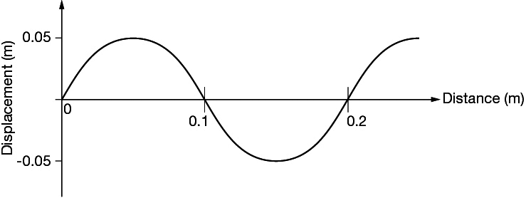

*1 mark for the correct amplitude and 1 for the correct wavelength*

**b** The graph above should include a dot at the 0.1 m mark on the curve where it crosses   
the *x*-axis. There should also be an arrow pointing upwards indicating that this point   
would be moving upwards. 1

Question 2

Longitudinal waves displace media in the same direction as the wave’s direction of   
propagation (e.g. sound). 2

Transverse waves produce a displacement of particles at right angles to the direction of propagation (e.g. water ripples, string vibrations). 2

Question 3

 1

Substituting *I*0 = 1370, *d*0 = 1 and *d*f = 1.5 gives *If* = 608.9 Wm-2. 1

Question 4

Destructive interference occurs when superimposed waves have opposite amplitudes and   
as a consequence partial or complete cancellation occurs. An example is when the crest of   
one water wave meets the trough of another water wave. 2

Question 5

**a** 0.4 s1

**b**  1

Question 6

Main concept counting towards each mark is in italics below.

Answer includes identification that *energy is transferred* from you across the valley  
and back. 1

Answer includes identification that the longitudinal wave in air is *reflected* off the opposite side of the valley. 1

Question 7

Hint: Draw a diagram.

The answer must correctly apply the law of reflection. 1

The answer is 0.75 m above the floor. 1

Sample answer:

The law of reflection states that the angle of incidence equals the angle of reflection. To see your feet light reflected off your toes must be able to reflect off the mirror and travel to your eyes. This occurs when the light reflects off the mirror at a height of half the vertical distance between your toes and your eyes. This is due to the condition that the angle of incidence   
must equal the angle of reflection. Therefore, your friend must place the bottom of their   
mirror no higher than 0.75 m above the floor to see their feet.

Question 8

Two appropriate differences indicated. 2

Sample Answer:

The wave travels at a slower speed in the second medium compared to the first.

If the angle of incidence to the normal is not 90 degrees then the direction of the wave will   
be different either side of the boundary. The waves will bend towards the normal as they   
cross the boundary.

Question 9

Once the person on the swing is moving they must be pushed with a frequency equal to the resonant frequency of the swing. If this is achieved then there can be an efficient transfer of energy to the swing and their amplitude of swing can increase. 2

Question 10

A standing wave is produced when two waves travelling in a medium meet in the same medium and have the same frequency/wavelength and the same amplitude. 3

Question 11

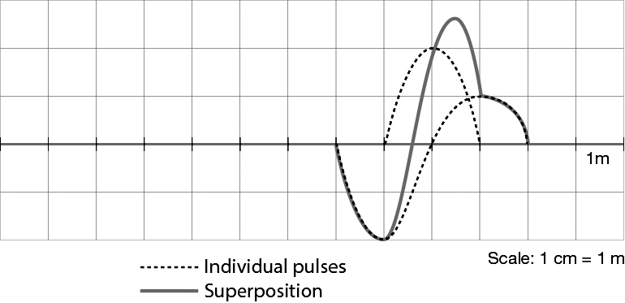

Correct amplitude and position of the two pulses shown after 2 seconds (green) 2

Correct shape/amplitude of superposition shown 1

Question 12

**a** The first harmonic has nodes at either end of the string where it is fixed (at the finger and the fixed end) and an antinode in the middle of the 0.5 m of string. 1

b 1

Question 13

a 2

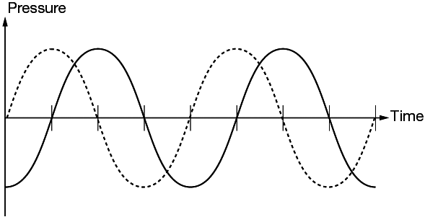

b The wave form arrives at B one-quarter of a cycle (and therefore one-quarter wavelength) after it reaches hearing aid A. This is a distance of 25 cm. 1  
Hence λ = 4 × 25 cm = 1.0 m 1

c *v* = *f*λ ⇒  2